Refilling   
Your  
Artist’s Well

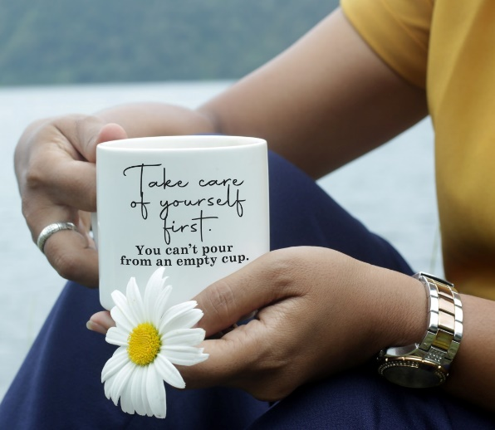

***Short snippets of inspiration  
from Anne Marie Bennett***

***KaleidoSoul.com***

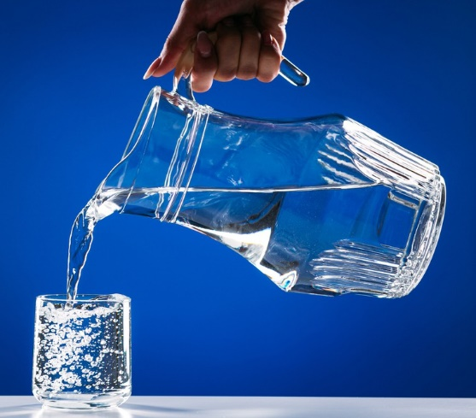***As artists, we must learn to be self nourishing.    
We must become alert enough to consciously replenish our creative resources as we draw on them-  
 to restock the trout pond, so to speak.***

***~ Julia Cameron***

Isn't this a great way to look at replenishing our creativity? Restocking the trout pond!  A little more picturesque than filling the well, but still and all, the same thing.  The message is deep and true, for everyone really, but for artists especially.  It is about taking a few steps back and seeing what we need.  It is about being ready—always ready—to give ourselves what we need.  To nourish ourselves, no matter the cost, no matter the opinions of others.

And it's not just about replenishing our art supplies—my glue stick has dried out and I need more mat board.  It's about refilling our spirits when we have run out of laughter.  It's about stocking up on whatever it is that keeps our creativity flowing.  It's about filling our lives with people who bring out the best in us.  It's about knowing ourselves so well that we are happy and willing to care for ourselves by giving ourselves whatever it is we need to live lives that we cherish and celebrate.

*\* What do you need for physical, spiritual, and artistic nourishment today?*   
  
*\* How can you give yourself exactly what you need?*   
  
*\* Is your inner artistic well full or empty right now?*   
  
*\* Have you* [*made a SoulCollage® card*](http://www.kaleidosoul.com/soulcollage-cardmaking.html) *yet for "I Am the One Who Knows how to nourish myself”?*

*\* Can you give yourself permission to give yourself what you need today?*

***Affirmation:   
I am focusing on ways to nourish my inner artist.***

***Art is the river that runs through my life.   
I drink from it as often as I can   
to refresh myself.  
  
              ~ Loretta Marvel***

Images of water have always been especially nurturing to me.  The ocean calling my name as its waves break steadily, rhythmically upon the shore.  The rain falling from heaven to parch barren, dry land.  And now this.  A river of art flowing by the open door that is my life, offering me a drink for renewal and rejuvenation.

A river of art.  What does that look like in my life?  For me, in this particular season, it is a river of magazines and images and SoulCollage cards, a river of crayons and chalks and juicy markers and tubes of bright acrylic paint, and an art journal- wide open, awaiting my response.  I welcome this river into my life.  I don't just drink from it, I swim in it!  It refreshes and renews my body, mind and spirit.

***\* If art is a river, what does it look like to you today?*   
  
*\* How can you move closer to this river which exists solely to sustain you?***

***\* Can you allow this river of creativity to flow as it will, around you and through you, or are you creating dams to block its nourishing currents from your life?  
  
* How can you use SoulCollage® to help you immerse yourself in this river?***

***Affirmation: I allow my art to nourish me.***

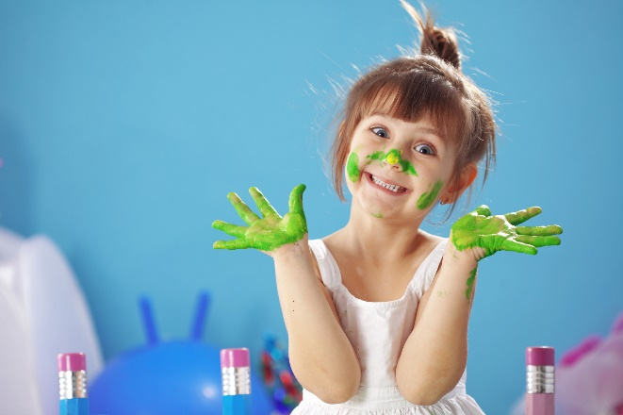***Every child is an artist.    
The problem is how to remain an artist   
once (s)he grows up.      
      
~ Pablo Picasso***

I know that some of you may be wanting to argue with this statement (even if it was made by one of the greatest artists of all time!).  "Yes," you might be saying.  "When I was a child I liked to draw, but I was just playing.  I can't really draw.  I'm not really an artist."

My claim is this: you don't have to be able to draw to call yourself an artist.  When it comes to drawing, my repertoire is limited to suns, flowers, and houses that look like they were drawn by a five-year-old.  Yet I am adamant when I use the word *artist* as one way of describing myself.  Anyone who can take this and that, and turn it into something else is an artist.  We do that when we make SoulCollage® cards.  We take a little glue and some scissors and turn pictures from magazines into works of art that express snippets of our soul.

It doesn't matter what your artistic background is, whether you've studied art for years or never taken an art class in your life.  If you are practicing SoulCollage®, if you have made even ONE SoulCollage® card, you are an artist.  And it is your work now to learn how to remain an artist, and how to let yourself remain one, as you continue to grow into your life.

* ***How comfortable are you with calling yourself an artist?***
* ***If you are uncomfortable, how can you become more at ease with this definition of yourself?***
* ***Can you make a SoulCollage® card for the artistic child inside of you, or for the Creator*** [***archetype***](http://www.kaleidosoul.com/archetypes.html) ***which guides your creative soul?***

 ***Affirmation:***

***I am an artist.***

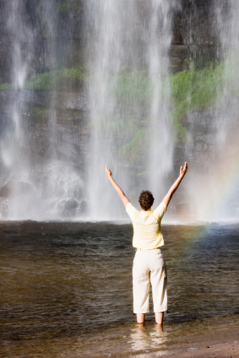

***The position of the artist is humble.***

***(S)he is essentially a channel. ~ Piet Mondrian***

If we are channels, then we must find ways to keep these channels open, so that the creative energy has a pathway to surge through, a means to its end.  How do we do this?

I find an easy way to answer this question by thinking of the things that *block* that channel inside of me . . . the things I do to distract myself from the art projects that lay strewn haphazardly over my two art tables. For example, I get too involved in what my overachiever voice calls "real" work.  Also, I overeat.  I forget to honor my inner artist.  I tell myself I don't have enough time.  I decide that other things are more important.

SoulCollage® helps me to keep the channel open.  Even something as simple as opening a magazine and looking for images that speak to my heart is instrumental in allowing the universe's creative energy to flow through me.

***\*  How are you***[***blocking the channel of creativity***](http://www.kaleidosoul.com/creative-blocks.html) ***your life this week?***   
  
***\*  What can you do today that will open you to the flow of artistic energy that is your birthright?***

***Affirmation:***

***Creativity flows easily and effortlessly through me today.***

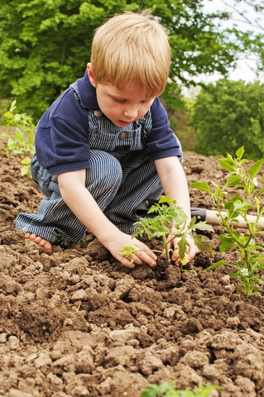

***I think that one's art is a growth inside one.    
I do not think one can explain growth.    
It is silent and subtle.    
One does not keep digging up a plant to see how it grows.***

***~ Emily Carr***

One year when I taught second grade, we did a science project where we planted sunflower seeds in paper cups and kept them on the windowsill.  The children took turns watering them.  For a few days, upon entering the classroom, they would rush immediately to the bright white cups on the gray ledge, as they chattered in breathless, reverent tones.

Then they lost interest.  It was just too *hard*, staring at the cups, waiting for their tiny seeds to sprout.  It was boring, they said.  Not interesting.  They put their attention elsewhere- homework to turn in, hamster babies to be counted and cared for, someone's new Gameboy.

Yet the miracle of growth continued, in spite of their nonchalance.  One morning, they were greeted with tiny, lush green leaves in their cups and they were properly awed.  "How did that happen?" demanded seven-year-old Lisa, her hands on her hips in stark amazement.

*"How?"*  I was stunned into silence as I searched for the right words.  How *does* a seed push its way through the dirt into the clean fresh air?  How *does* a baby turn into a young man right before our eyes?  How *does* an artist grow into that place inside of her where she is open to truth and beauty and self-acceptance?

*\*  What seeds have been planted inside of you in the past year?*

*\*  What are you thinking, hoping, praying that these seeds will turn into?*

*\*  Look back over the last five years of your life and notice how you have grown and changed, in both your outer and inner lives.*

*\*  How can SoulCollage® help you to plant seeds of artistic growth within?  How can you use SoulCollage in your life to help you to grow?*

***Affirmation:   
My life is full of growth, seen and unseen.***

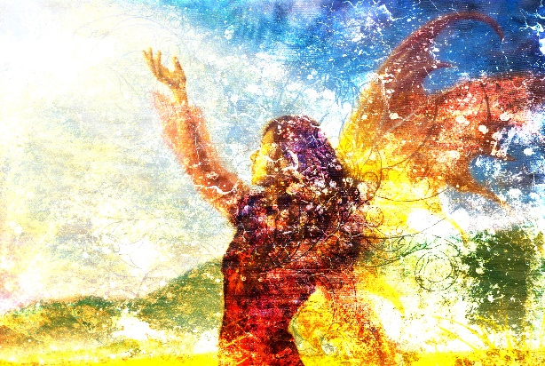

***Inside you there's an artist   
you don't know about...***   
***Say yes quickly, if you know,   
if you've known it from before***

***the beginning of the universe.    
  
 ~ Rumi***

From time to time, I come face to face with the part of me who taunts my artist self with words like, "Ha! *You* are not an artist," and "You can't call yourself a REAL artist unless you paint with oils and your pictures sell for thousands of dollars."

Sound familiar?

I think we all have an inner Bullying Babe, Connie the Critic, or Doubting Donna, whose main goal in life is to shut down our creativity.  Yours may have a different name, but their purpose is the same.

I find that the only true way to lower the volume on these voices is to *stand firmly in my own conviction that I am indeed an artist*.  Maybe my work isn't hanging in any galleries, but my friend was touched by the handmade birthday card I sent her last week.  Maybe I use crayons and magic markers in my art journal instead of watercolors, but when I express myself with them I feel happy and whole inside.

*\*  What does the artist inside of me look like?*

*\*  Can I make a SoulCollage® card to honor the* [*inner voice*](http://www.kaleidosoul.com/innervoices.html) *of my playful artist?*

*\*  What does my inner artist need from me today?*

***Affirmation:***

***I am an artist.***

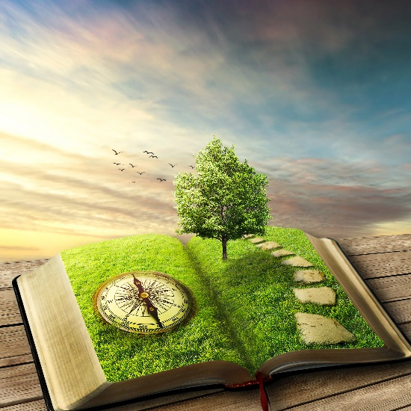***Stories are medicine.    
  
~ Clarissa Pinkola Estes***

I was watching the Robert Redford interview from *The Actor's Studio* the other day and learned something new.  One of his passions has always been telling stories.  He spoke of growing up with stories being a part of the fabric of his daily life.  Stories were told to teach lessons.  Bedtime stories were a given.  He grew up drawing and sketching, and writing stories.  I didn't know this about him.  His artistic gifts all seem to be intertwined—artist, writer, actor, director.  His art informs his writing which gives him breadth as an actor and deep vision as a director.  And *all* of it stems from a love of storytelling!

I gravitate toward novels and stories that tell deep, passionate stories about real human beings.  Plays and musicals thrill me inside when they are burning to tell a powerful, true story. To me, a "good" piece of art tells a story too.  Look at your favorite painting, your most-loved photograph, your most treasured SoulCollage® card.  Are there not stories there?  And are those stories not medicine to your soul?  They are indeed.  They are Medicine which soothes the spirit the way aspirin soothes a headache, medicine which takes our twisted journeys and straightens them into magnificent things, stories worth loving and sharing.

***\*  What story does your favorite*** [***SoulCollage® card***](http://www.kaleidosoul.com/soulcollage-gallery.html)***tell about you, about your journey on this planet?***

***\*  Who can you share that story with today?***

***\*  How does the story of your life show in your art?***

***Affirmation***

***I tell the story of my life with my SoulCollage® cards.***

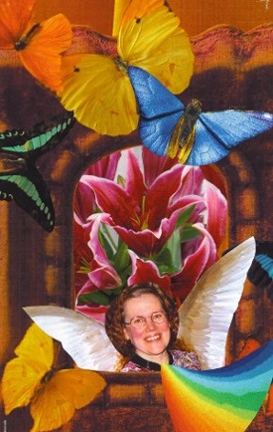

***When the spirit does not work with the heart***

***there is no art.***

***~ Leonardo Da Vinci***

Years ago, in a session with my therapist (Fran), we discussed the concept of *being enough*.   I had made a SoulCollage® card to give image and voice to the part of me who believes that she *isn't* enough.  Fran and I had done some work together with that voice, and then we began focusing on the part of me who believes that *I am enough*.  "What can you do to remind yourself about this part of you?" Fran asked.

I decided to make a SoulCollage® card for this part of my self, so that week I set about going through magazines to find the right images.  Of course, first I had to go inside and really *look* at this piece of me.  What does *being enough* look like?  What does it *feel* like?  I wasn't quite sure.  As I looked through the images, I decided to trust that Spirit would show me.  And guess what?  The card just about made itself!  As I trusted the process and set the intention to make this card, several beautiful images presented themselves in a short period of time: an open window, bright butterflies, a pair of feathery white wings and a headshot of my own beautiful self!

My *I am the one who is enough* card is one of the most precious cards in my deck.  It is special to me because my hands did the cutting and the pasting, but Spirit did the rest, and I *allowed* that to happen.

***\*  Are you allowing Spirit to work with your hands as you create your art this week?***

***\*  How can you step aside to let Spirit weave its magic into your art?***

***\*  Can you set your rational, reasoning self aside the next time you make a SoulCollage® card?  Can you allow Spirit to choose the images and create the card?***

***Affirmation:***

***I allow Spirit to breathe new life into my art.***

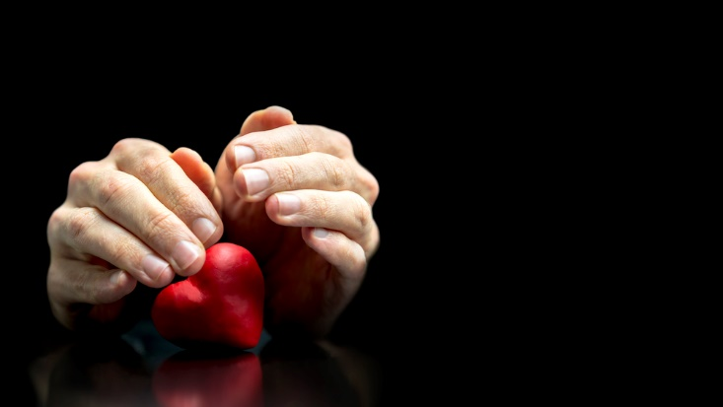***As an experienced artist,***

***I carry my work like a secret pregnancy.***

***I am always aware of inner life***

***and the need to protect it.***

***~ Julia Cameron***

I have many SoulCollage® cards, and I lead workshops and groups all the time, but I don't share *all* of my cards with *everyone*.  Some of the cards, at this time, are for my eyes only.  Some of the cards are about deep places inside of my soul that I'm not ready to share yet.  Just as a baby in its mother's womb is not ready to face the world, so too there are pieces of my art resting inside of me, waiting for the cycle of completion to spin one last time.

There is nothing wrong with this.  It is totally up to *me* to be aware of my art and its connection to my soul.  It is up to *me* to decide which of these parts need protection, and which of them need sunlight.

***\*  What art pieces are you currently working on?  Picture the pieces in your mind. They might be SoulCollage® cards; they might be watercolors, sketches, sculptures, mixed media collages, quilts, embroidery.  They are yours. Picture them.  name them.***

***\*  Do any of these pieces need protection from the world right now?***

***\*  What steps can you take to ensure the safety of your art?***

***\*  What measures can you take to keep your soul out of harm's way?***

***Affirmation:***

***I allow Spirit to breathe new life into my art.***



***The primary benefit of practicing any art,***

***whether well or badly,***

***is that it enables one's soul to grow.***

***~ John Welwood***

This is the exact thing which I love so dearly about SoulCollage®.  There is no right way to do it! This generous permissiveness, the expansive expression, is exactly what allows my soul to grow into a brilliance that knows no boundaries, no rules.

This doesn't just pertain to SoulCollage®.  No matter what kind of art we practice (music, dance, painting, scrapbooking, altered art, collage, acting, filmmaking, writing . . .), it must be done with the same spirit of *no right way,* the same intention of showing up and practicing faithfully and passionately, without judgment, and most of all—without beating ourselves up.

***\*  Are you practicing your art with the intention of growing your soul, or the attitude of perfectionism?***

***\*  What one thing can you do this week to widen the boundaries around your art?***

***\*  What one thing can you do this week to let go of wanting/needing everything to be perfect?***

***Affirmation:***

***The only right way in my art is MY way.***

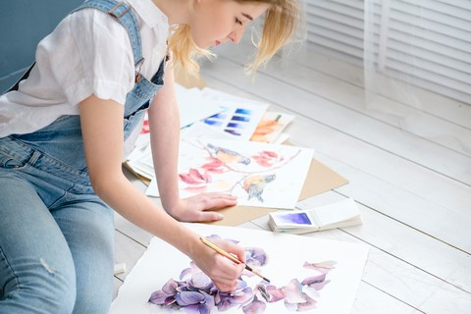***People who love art really do need it***

***in the same way they need oxygen.***

***~ Martin Zimet***

I am thinking right now of how my art (including my SoulCollage® work) feeds me.  How it nourishes me, sustains me, makes me breathe easier, makes my body feel lighter, brighter.  I am also thinking of the many years when I ignored my artistic voice, when I didn't know that it was okay to color with crayons and fingerpaints even though I'm more than half a century old.  Of the many days and nights when I denied myself the pure pleasure of creating collages from paint and ribbon and shells and words, the deep satisfaction of the sound of my soft paintbrush as it swooshes paint onto a fresh canvas board.

Right now, I'm at a place in my life where I can't stop this artistic expression, no matter what.  I love it too much.  I need the affirmation it gives me; I need the outlet of spreading my soul onto paper with markers, with paint, with crayons, chalks, and magazine images.  I need it because it helps me define who I am.  I need it because color and art feed my soul with the oxygen of color, image, and gift.

***\*  Do you remember a time in your life when you denied yourself the gifts that your art gives you?  What does it feel like to remember?***

***\*  How can you make your art a priority in your life? Will you need to change something for this to happen?***

***Affirmation:***

***I allow my art to be as crucial to me as breathing.***

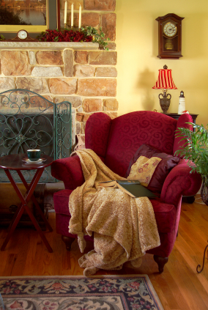***Art should be something like a good armchair  
in which to rest from physical fatigue.***

***~ Henri Matisse***

My husband bought a recliner several years ago.  He tried it out in the store, chose a color that went with our bedroom decor, and had it delivered.  I loved his enthusiasm for this chair, but when I sat in it, I couldn't seem to get comfortable.  It turns out it suited him perfectly because he has short legs and a long torso, but my body is the opposite.

I kept this in mind when I was shopping for an easy chair for my study several months ago.  I made sure to not only look at colors, fabrics, and price, but to how it felt when I sat in it.  Believe me, I sat in quite a few before I found the right one!  I knew immediately that it "fit" my body because as soon as I sank into it and pushed back into reclining mode, my body and mind echoed the same chorus: "Ahhhhh, yes!

According to Matisse, I should look at my art in the same way.  There are so many modes of artistic self-expression, so many paths of creativity to choose from.  Pottery, sculpting, scrapbooking, altered books, beadwork, jewelry making, altered art, rubber stamping, watercolors, gardening, oil painting, knitting, furniture refinishing, crayons, chalks, collage . . . The list goes on and on. It's my job as an artist to fit my artwork to my inner and outer needs, at any given moment.  It's my job to find a manner of self-expression that "fits" me just right.

***\*  Which*** [***kinds of art***](http://www.kaleidosoul.com/expressiveart.html) ***serve me with physical, emotional, and spiritual rest?***

***\*  How can I incorporate more of this type of art into my life?***

***\*  Is there an art form I am using that doesn't serve me in this way?  How is it serving me instead?  Do I need to continue with this art form or can I let it go?***

***\*  Can I make these choices based on my needs at any given moment?***

***Affirmation:***

***My art provides me with a restful sanctuary.***

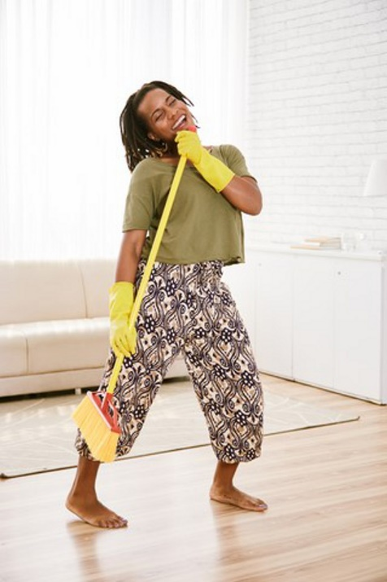

***Art is like singing.    
Some do it better than others,   
but everyone can and should   
be doing it for their soul.***

***~ Barbara Mason***

I love to sing and to tell the truth, I'm no Whitney Houston, but I can carry a tune!  There are others who can't carry a tune; they understand this and keep their mouths shut.  But they are missing out on one of the greatest pleasures of life—singing.

Remember that scene from *My Best Friend's Wedding*?  The Cameron Diaz character is goaded into getting onstage and belting out a karaoke number in front of her fiancé and his best friend.  She *can't* sing, and she knows it, but she does it anyway.  She sings badly (very badly, in fact), but she sings from her heart, and this is the only thing that her fiancé hears—no sour notes, no warbly soprano, just the song coming from her bright inner being.

Now, back to the subject of the quotation above. I am an artist. I love to play with colors and shapes and textures.  I love to create art.  I'm pretty good at what I do.  I'm no Vincent Van Gogh, but I make beautiful mixed media collages, and meaningful [SoulCollage® cards](http://www.kaleidosoul.com/soulcollage-gallery.html).  I do this because I love to do it, because it helps me to know more clearly who I am.  Even when the pieces I create aren't so great in the commercial sense, I still love them because they came from inside of me . . . they came from my soul.

***\* Do you compare your art with other artists' work?***

***\* Does your art come from within you?***

***\* Are you creating your art for your soul, or for some other reason?***

***\* Create a piece of art this week that is for no one but yourself.***

***Affirmation:***

***My art feeds my soul.***

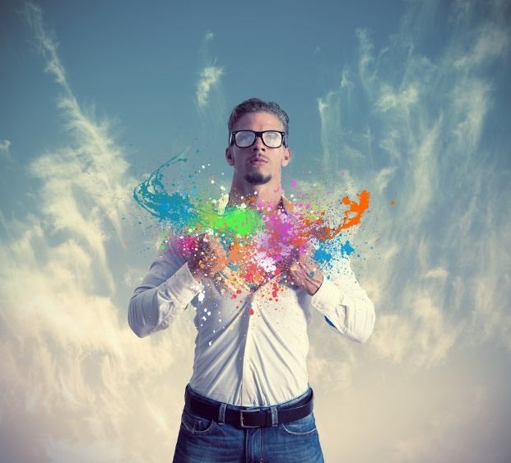

***Art enables us to find ourselves  
and lose ourselves at the same time.***

***~ Thomas Merton***

A few years ago after my mother died, I found it difficult to get back into my art.  Some of it was the day-to-day difficulty of dealing with paperwork, probate, and helping my brothers dismantle her apartment. Some of it was due to depression and grief.  She was an artist herself and I couldn't seem to bring myself to sit at my art table and do the things that she also loved to do.

Several months later I saw a musical at the theatre where I worked, and was so caught up in the magic of it that I wanted to make note cards for the cast as a thank you for an evening of laughter and delight.  When I got home, I went immediately to my art table and began creating a design that reflected the theme of the show, then duplicating it into twenty-three thank you cards.  My heart was content and all was well.  I was swept up into the act of creation.  I could hardly believe it when I looked up at the clock and saw that it was 3 a.m.!

I am glad that I trusted my inner yearning to create again because, as those five hours flew by, I completely lost all sense of time and place.  All that mattered was the creating, and this creating also enabled me to find myself again.  After so many months of holding myself back from the paper, the paint, and the creative juices bubbling within me, I allowed myself to be led back to it, and in doing so, I found myself again.

***\*  When was the last time you lost track of time while you were creating art?***

***\*  How did that feel?***

***\*  What kinds of art do you do that enables you to connect with yourself at your deepest core?  Set an intention to do some this week.***

***Affirmation:***

***I use my art to connect to my soul.***

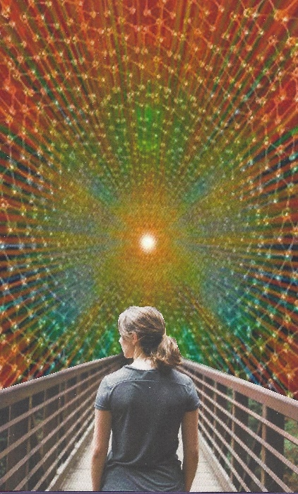

***The grace to be a beginner  
 is always the best prayer  
for an artist.***

***~ Julia Cameron***

I thought it appropriate to end this series with a quotation about beginning.  It occurs to me that whenever I sit down to start a new project, I feel like a beginner.  Because every time I decide to create something new, I am starting all over.     
  
It takes a beginner to look anew at a blank sheet of paper.  It takes beginner's mind to not let previous projects and ideas get in the way of what this new piece wants to be.

***\*  What is the next project or SoulCollage® card you want to work on?***

***\*  Can you let go of any preconceived ideas of how you think this project ought to turn out?***

***\*  Can you take a deep breath and allow yourself to go with the*** [***flow of creativity***](http://www.kaleidosoul.com/creative.html) ***as it happens?***

***Affirmation:***

***I approach each new creation with the fresh mind of a beginner.***