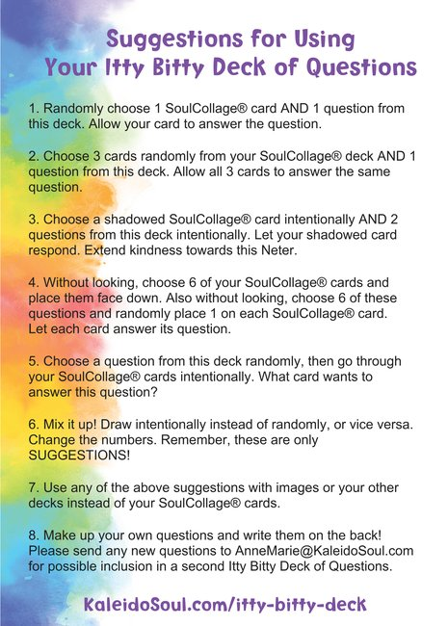

**Don’t forget your home page for more ideas and ways to use the Itty Bitty Deck:**[**www.KaleidoSoul.com/ideas-page**](http://www.KaleidoSoul.com/ideas-page) **Password: ideas**