Tending Your Dreams with SoulCollage® - Teleclass 11.25.13
Red Line Collage Sequence

1. Dream Scene


2. Red IS!

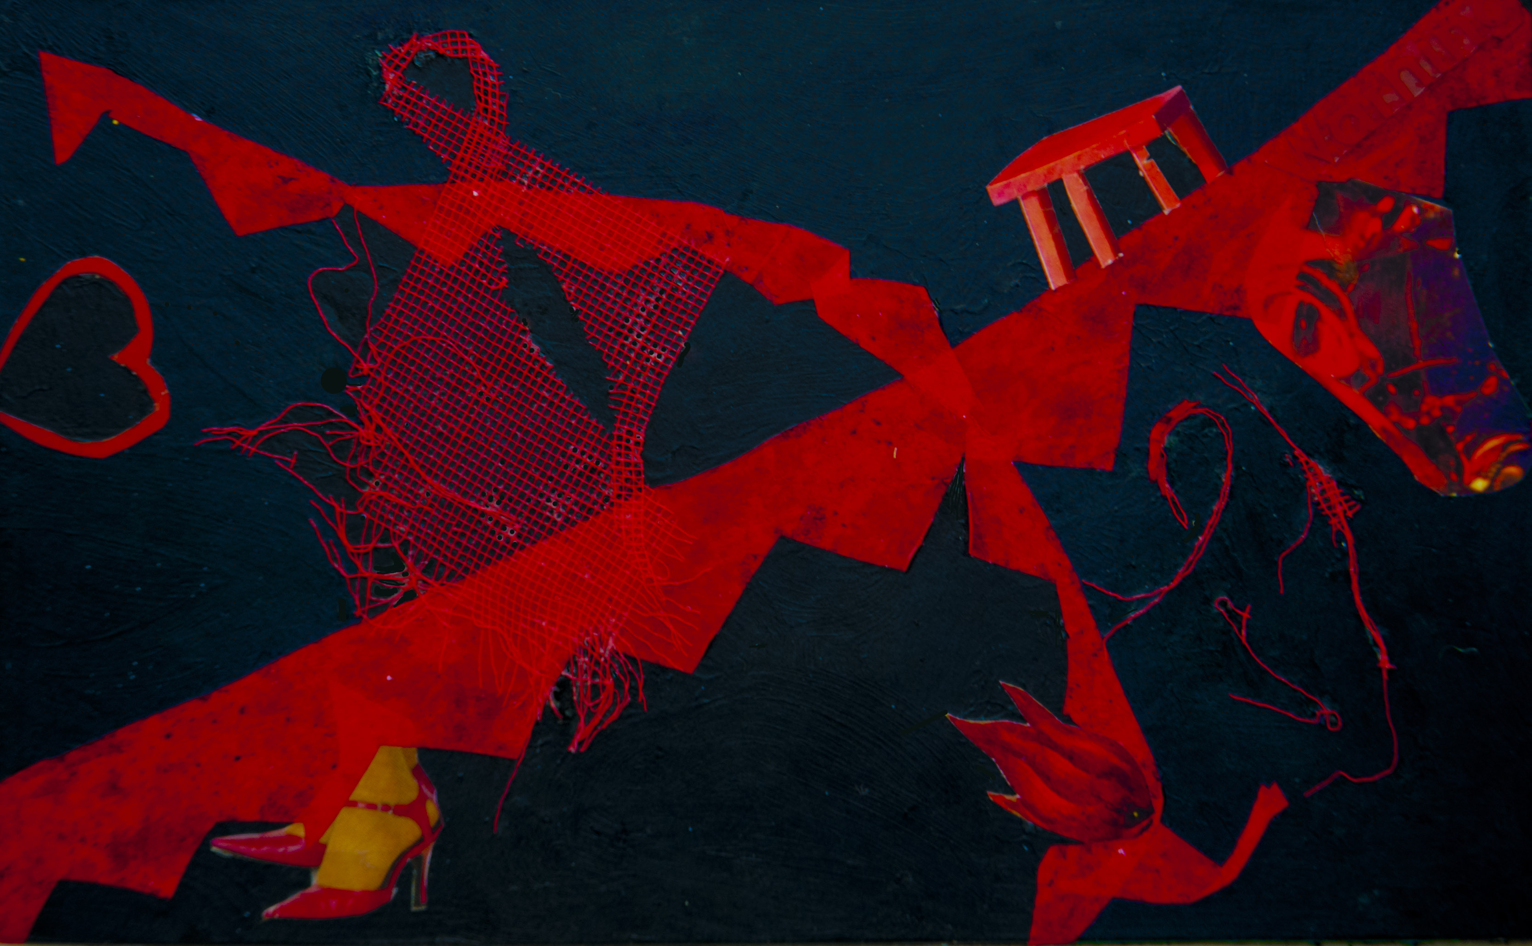
Red Lady cries out for mattering:
threads in motion--elements,
essences moving from possibility
into manifestation.

With a dream in her eye, Heart
knows the way. Heart first, always.
This is the story of dancing shoes,
migration and new beginnings:
vital fires, flowing.

Can I imagine such power?
Can I allow it?

I must.

Nancy L. Weiss, LCSW, BCD, Psychotherapy, Spiritual Direction, SoulCollage® Facilitation, Phone: 323-934-5484; Email: nancyweiss@gmail.com; Website: www.nancyweisslcsw.com
3. Knows the Alchemy

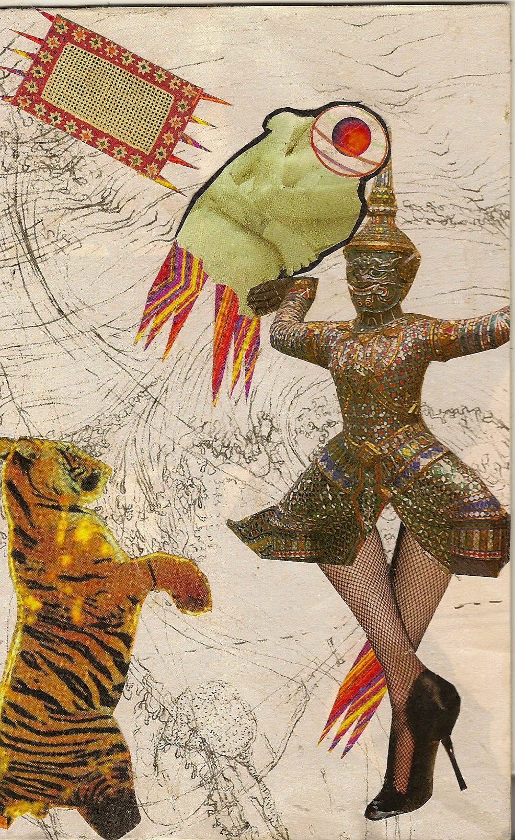

attached at last to meteor’s tail,
wearied wary one casts off
and I, born of Gevurah,
grasp hold of Tiger’s paw.

I am one who joins with Tiger: dark
with light; wildness with willful discipline;
warrior with dame in fishnet stockings
and spiked heels—fierce power
with fierce power.

ravishing beauty startles;
fierce power pierces/blazes!
looking at life from both sides now—
swirling, whirling on the spiraling edge:

alchemy of two worlds meeting;
fire and grace.

Nancy L. Weiss, LCSW, BCD, Psychotherapy, Spiritual Direction, SoulCollage® Facilitation, Phone: 323-934-5484; Email: nancyweiss@gmail.com; Website: www.nancyweisslcsw.com
4. Into Her Arms

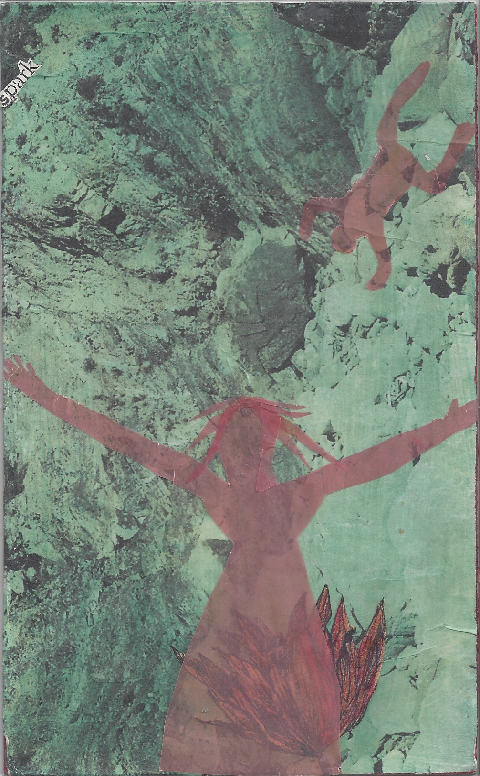

into Her arms I fall—or dive or fly:
it’s all perspective; no matter what,
I am reaching, and she is reaching—
two yearning hearts coming together,
and I am crying out to her and she,
to me—both of us gifts—pure passionate
wanting: mine, hers—ours now;
in the background, songs of endless
renewal, in the background:
Source of Creation.

She reaches, I reach

Nancy L. Weiss, LCSW, BCD, Psychotherapy, Spiritual Direction, SoulCollage® Facilitation, Phone: 323-934-5484; Email: nancyweiss@gmail.com; Website: www.nancyweisslcsw.com
5. I’m Going To…

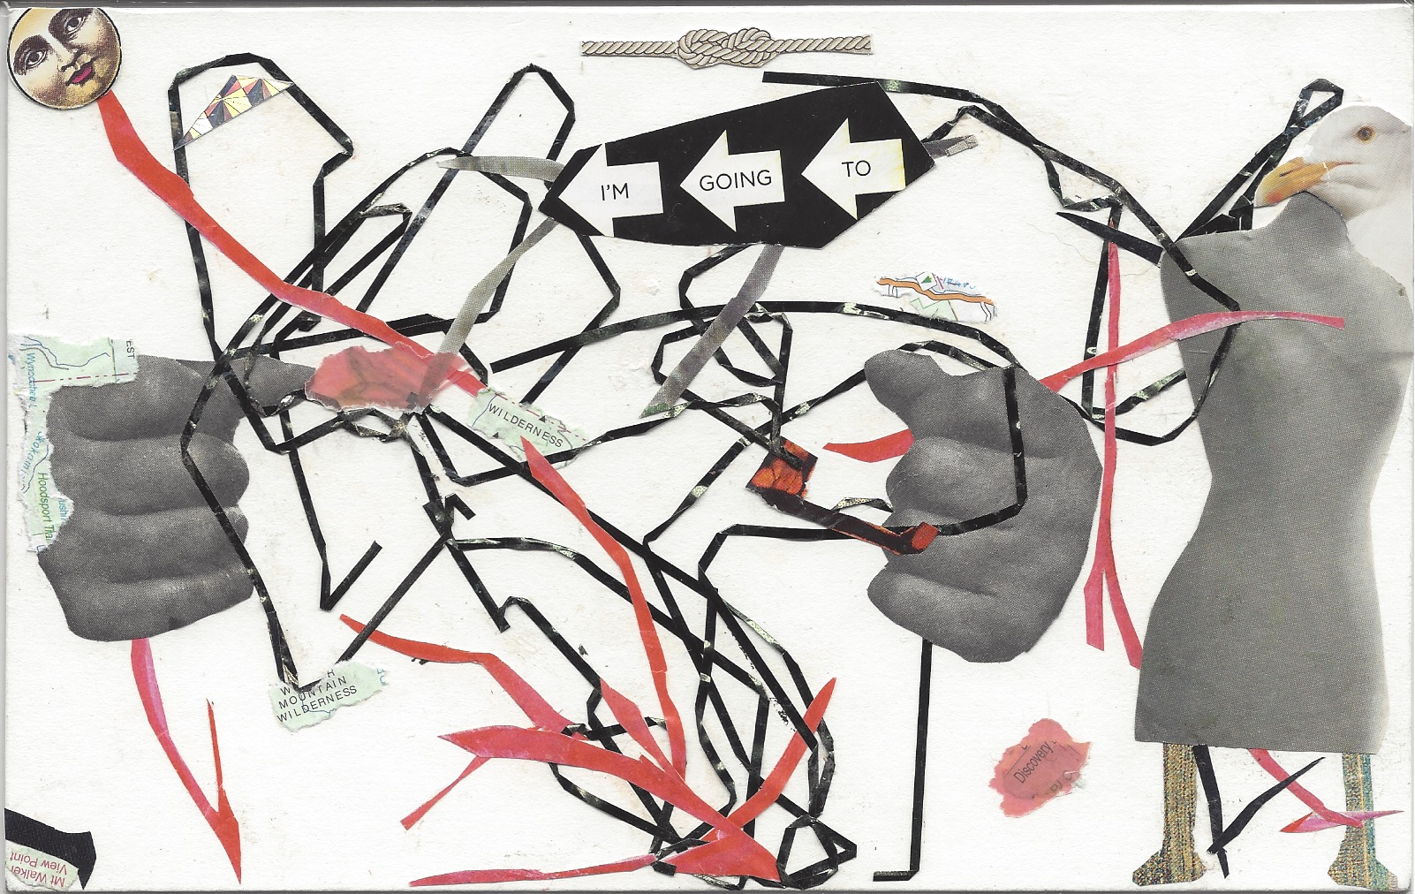

Nancy L. Weiss, LCSW, BCD, Psychotherapy, Spiritual Direction, SoulCollage® Facilitation,
Phone: 323-934-5484; Email: nancyweiss@gmail.com; Website: www.nancyweisslcsw.com

